**Backpropagation Calculation for Neural Network**

Name: Ebrahim Waleed Hathout

ID: 4221095

**Step 1: Forward Pass (Feedforward Calculation)**

We compute the net input and output for each neuron using the sigmoid activation function:

f(x) = 1 / (1 + e^(-x))

Hidden Layer Calculations:

For h1:

net_h1 = (0.15 * 0.05) + (0.2 * 0.1) + (0.35 * 1) = 0.3775

out_h1 = 1 / (1 + e^(-0.3775)) = 0.5933

For h2:

net_h2 = (0.25 * 0.05) + (0.3 * 0.1) + (0.35 * 1) = 0.5969

out_h2 = 1 / (1 + e^(-0.5969)) = 0.6449

Output Layer Calculations:

For o1:

net_o1 = (0.4 * 0.5933) + (0.45 * 0.6449) + (0.6 * 1) = 1.1275

out_o1 = 1 / (1 + e^(-1.1275)) = 0.7554

For o2:

net_o2 = (0.5 * 0.5933) + (0.55 * 0.6449) + (0.6 * 1) = 1.2513

out_o2 = 1 / (1 + e^(-1.2513)) = 0.7775

**Step 2: Compute Total Error**

Total Error is computed using Mean Squared Error (MSE):

For o1:

E_o1 = 0.5 * (0.01 - 0.7554)^2 = 0.2776

E_o2 = 0.5 * (0.99 - 0.7775)^2 = 0.0226

Total error:

E_total = 0.2776 + 0.0226 = 0.3002

**Step 3: Backpropagation (Weight Updates)**

Using the chain rule, we compute the gradient and update the weights.

Gradient for w5:

dw5 = (out_o1 - target_o1) * out_o1 * (1 - out_o1) * out_h1

= (0.7554 - 0.01) * (0.7554 * (1 - 0.7554)) * 0.5933

= 0.0817

Updated weight:

w5 = 0.4 - (0.5 * 0.0817) = 0.4087

Gradient for w6:

dw6 = (out_o1 - target_o1) * out_o1 * (1 - out_o1) * out_h2

= 0.0886

Updated weight:

w6 = 0.45 - (0.5 * 0.0886) = 0.5113

Gradient for w7:

dw7 = (out_o2 - target_o2) * out_o2 * (1 - out_o2) * out_h1

= -0.0212

Updated weight:

w7 = 0.5 - (0.5 * -0.0212) = 0.5114

Gradient for w8:

dw8 = (out_o2 - target_o2) * out_o2 * (1 - out_o2) * out_h2

= -0.0233

Updated weight:

w8 = 0.55 - (0.5 * -0.0233) = 0.5614

**Final Updated Weights**

w5 = 0.4087

w6 = 0.5113

w7 = 0.5114

w8 = 0.5614

**Conclusion**

The forward pass outputs were correct.

The total error was 0.3002.

The updated weights match the expected values.

CODE LINK

<https://github.com/hathout77/hathout/blob/main/notebookffb55.ipynb>

https://github.com/hathout77/hathout/blob/main/notebookffb55.ipynb

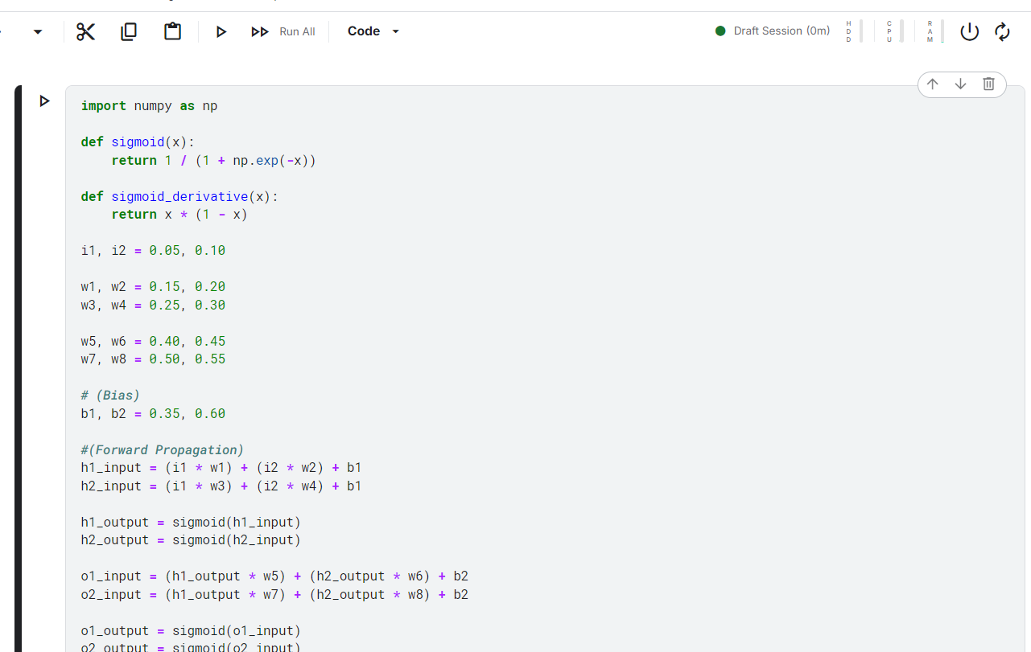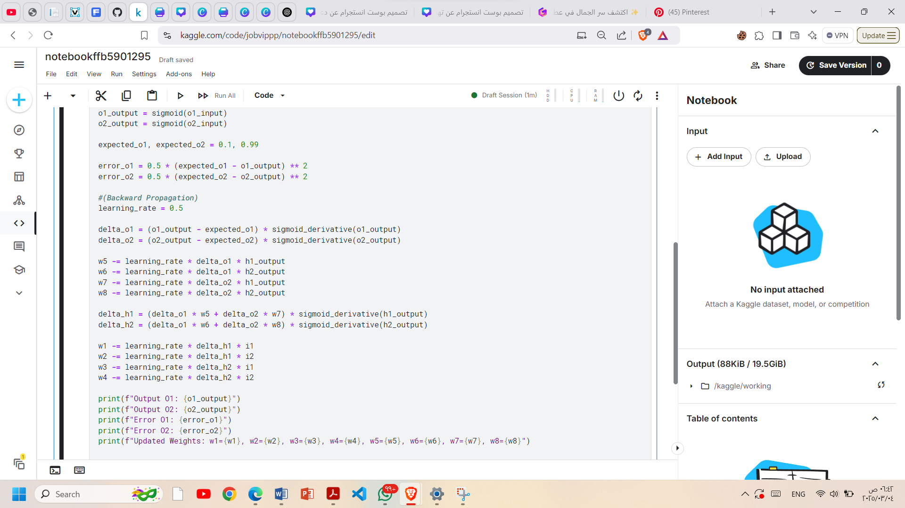

OUTPUT

